**Tableau- Assignment 4**

1. Draw a comparison between discrete and continuous dates in tableau and illustrate one example for each by plotting a comparison chart using the PowerStore_USA data.

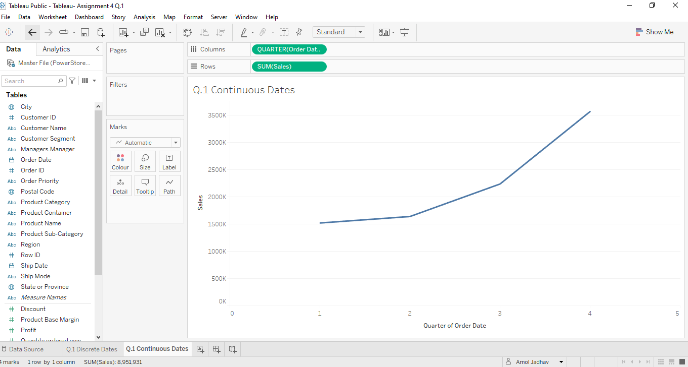

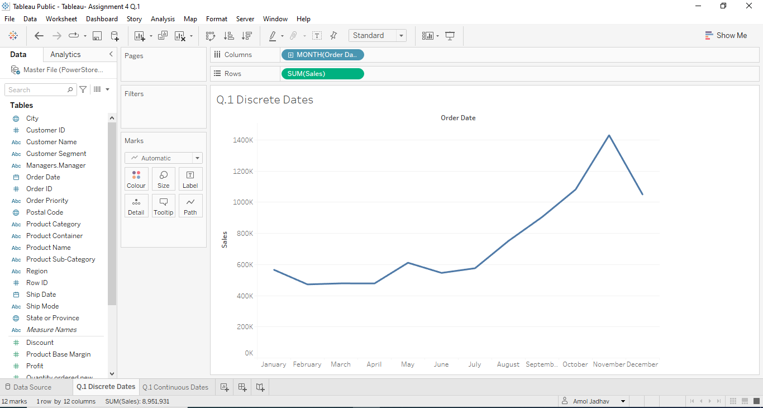

1. Imagine that you are given a dataset with various states of India but the data is not cleaned properly and may have entries like “Jammu” and “Kashmir” and “Andaman” and “Nicobar Islands” separately, even though both of these elements are referring to the same state. Create a dummy states data with the columns( States and STD Code) with the conditions mentioned above and read the data into your tableau desktop. Using a common tableau feature, combine the elements which have been referred twice. For example, entity “Jammu” and entity “Kashmir” should look like ““Jammu Kashmir” and so on.

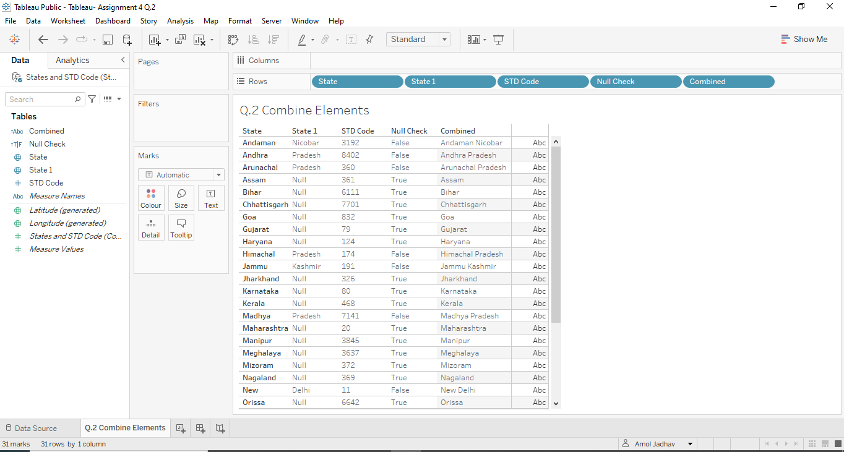

1. A "Set" is a portion of your data that satisfies criteria based on the currently available dimensions. You can generate a subset of data depending on certain conditions using a set. A set can be either a constant set or a calculated set. Create a view showing IN/OUT members of "Products with profits greater than 400000" set. Use the “NorthSeaExports.xls” dataset.

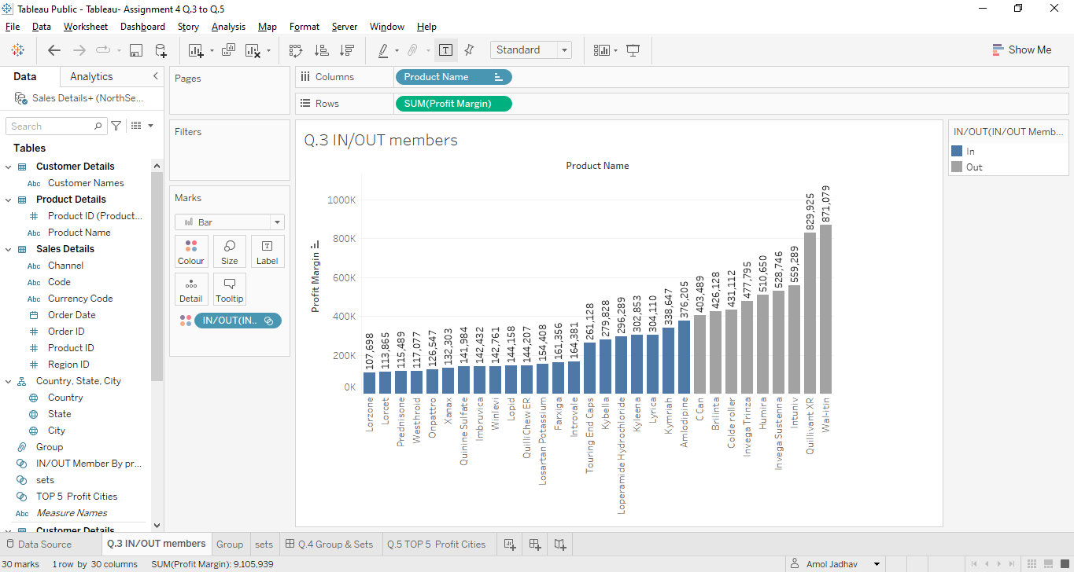

1. Compare and contrast the use of Sets and Groups in Tableau. Highlight at least 2 differences each with help of illustrative examples. You can use any dataset of your choice.

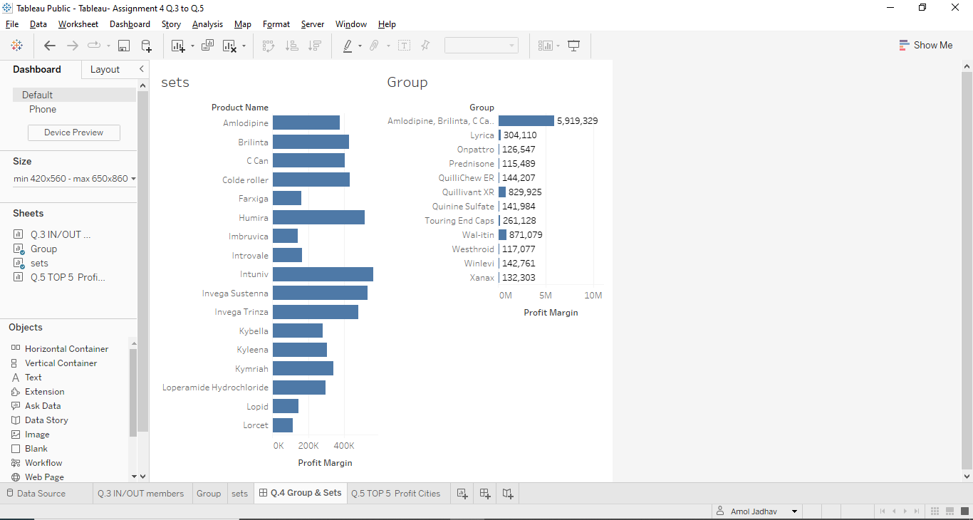

1. Filters, computations, and other processes can employ parameters in place of constant values because they are dynamic variables. With reference to the above piece of information, create a view depicting “TOP 5 States” based on their “Profit.”

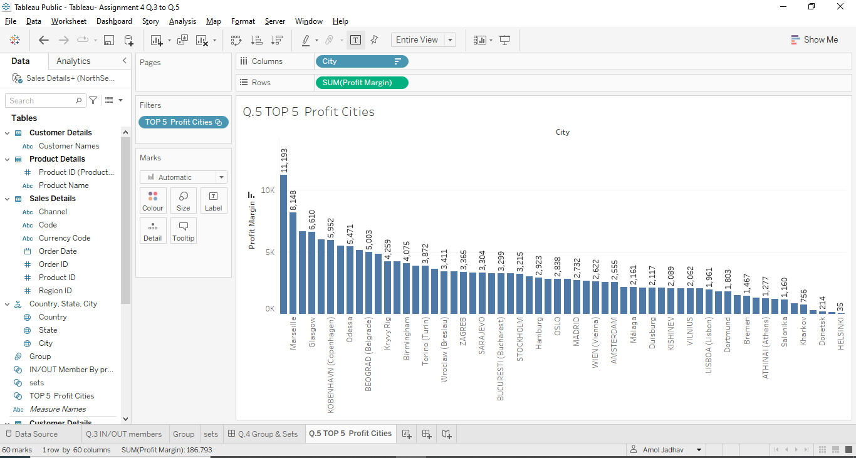

[*PFA links for the datasets used.*](https://drive.google.com/drive/folders/123UyMRbrReCjyn1K4g_FhsjKx6cP4zLH?usp=sharing)